## 

## Big Data in Education Industry

## 

## 

**Table of Contents**

Introduction 3

Project Landscape 4

Technology Adoption 5

The Impact of Big Data on Education 6

Solution Analysis of Big Data 9

Data Governance & ROI 12

References 14

## 

## Introduction

Higher education institutions need to record all academic related data from various activities, such as students’ data, instructor data, courses data, registration data, assessment data, etc. Due to the advancement of information technology, social interactions have increasingly moved online. These online interactions can be traced and collected, will form a huge amount of data, and can be considered big data. The higher education sector faces challenges in data collection and analysis due to inadequate IT infrastructure, tools, and human expertise. Also, while collecting and analysing student data, higher education institutions face some challenges like privacy, safety, and security issues (Minimol Anil Job, 2018). Exploring big data in education requires understanding why this industry is chosen for analysis. Higher education faces the challenge of recording diverse academic data as social interactions move online, generating substantial big data. However, implementing big data solutions encounters hurdles due to insufficient IT infrastructure, tools, and expertise. The nuanced process of collecting and analysing student data raises additional concerns about privacy, safety, and security, highlighting the multifaceted challenges in utilising big data in education (W. Labib,D. Eman Abowardah, 2023).

The types of big data available in higher education sectors will provide a variety of opportunities that help improve student learning, such as better learning as a result of faster and more in-depth diagnosis of learning needs or course trouble areas, including assessment of skills such as systems thinking, collaboration, and problem solving in the context of deep, authentic subject-area knowledge assessments. Project assessment is revolutionised by integrating Big data from various data sources, enhancing collaboration skills, learning, and problem-solving, thereby enhancing efficiency and customer satisfaction.

## Project Landscape

In today's fast-paced world, big data has grabbed a lot of attention due to its resourcefulness and wide use. It has revolutionised the way we collect, store, analyse, and process data. Several industries are using big data for various purposes, including health, banking, economics, and education. The advent of big data in education has revolutionised the traditional learning approach and led to a new data-driven approach for decision making and advanced analytics have transformed the landscape of teaching, learning, and administrative processes. The possession of big data can definitely produce new knowledge and intuition in the education sector (Wang, 2016).

Big data in education has at least two of the major applications that have digitised the education system. First, the digitization of collecting and storing institutional data in traditional settings results in maintaining standardisation in student information, i.e., the Student Information System (SIS). Second, analysing the learning behaviour and patterns of students for educators becomes mostly digitised using the learning analytics platforms. Learning management systems are widely adopted by institutions to manage study materials, assignments, and assessments. Including these, here are some more major big data applications and projects prevalent in the education industry:

1. Learning Analytics
2. Adaptive Learning Systems
3. Predictive Analytics
4. Personalised Learning
5. Educational Data Mining
6. Administrative Efficiency and Planning

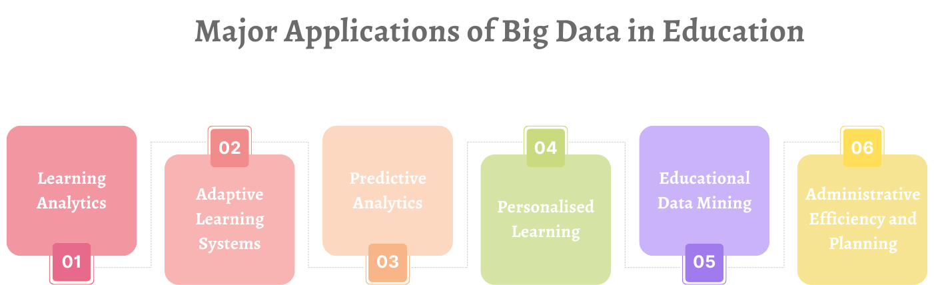

**Figure 1** | List of major big data applications in education industry

The education sector utilises big data to make data-driven decisions and analyse institutions' market reputation and value, despite the vast amount of data generated.

## Technology Adoption

The education industry has undergone a transformative shift through the integration of big data technologies. This project explores key technologies in the adoption of big data, examining their implications and potential benefits for education. From learning analytics platforms to cloud computing, each technology plays a pivotal role in shaping the future of educational practices (Baig,M., Shuib, L., & Yadegaridehkordi, 2020).

**Key technologies and tools in use**

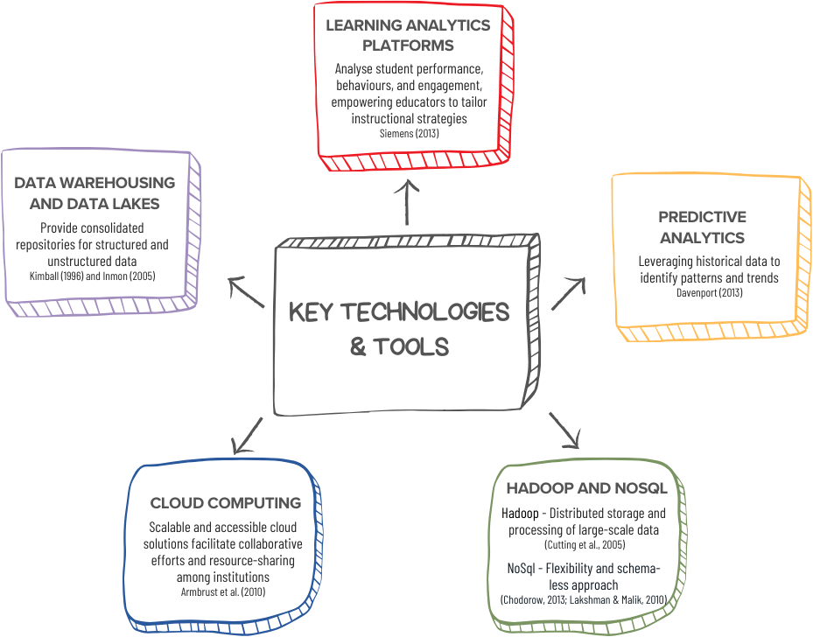

**Figure 2** | Key technologies and tools of big data to be used in education industry

**Reasons behind technologies selection**

The preference for certain technologies in big data adoption within the education industry is driven by distinct factors. Technical capabilities play a crucial role, with learning analytics platforms chosen for advanced analytical features and data warehousing and data lakes selected for efficient data management.

Scalability is another determinant, with cloud computing providing on-demand resources and Hadoop and NoSQL databases offering the ability to handle large-scale and diverse datasets.

Adaptability is a key consideration, leading to the adoption of machine learning and artificial intelligence platforms for personalised learning experiences and NoSQL databases for flexible data structures.

# 

## The Impact of Big Data on Education

Big data technologies are used to extract valuable and meaningful information from vast volumes of a wide variety of veracity and fast-growing data. Using big data to develop different types of applications for education data mining, extracting knowledge from those data helps education sectors such as schools and universities be smarter. The role of big data in education is significant as it helps to improve the learning process and make educational content more efficient. We've compiled detailed information on the direct and indirect transformations that big data brings to the education sector, along with its strengths and weaknesses (Drigas, A. S., & Leliopoulos, P, 2014).

### Direct Impact:

1. **High Level of Personalisation:**
   * Directly influences the learning experience of students by providing customised learning programmes tailored to their unique needs and preferences.
2. **Effective performance measurement:**
   * Directly affects the efficiency of the assessment process for teachers, making it faster and more accurate, eliminating bias, and allowing for more personalised feedback to students.
3. **Active Participation and Engagement:**
   * Directly contributes to increased student engagement and active participation in the learning process through customised programs and engaging learning materials.
4. **Access to Studying Process Analytics:**
   * Directly empowers teachers and professors with data analytics to assess students' performance and make informed decisions to enhance the learning program and provide additional support.
5. **Better Student Results:**
   * The enhanced learning environment and access to a diverse range of effective materials directly contribute to improved academic performance.

### Indirect Impact:

1. **Improved Teaching Efficiency:**
   * Indirectly enhances the efficiency of teachers by automating routine tasks such as grading, allowing them to focus more on in-person communication and delivering complex material effectively.
2. **Enhanced Learning Environment:**
   * Indirectly creates a more conducive learning environment by promoting active learning, engagement, and the use of interactive materials, leading to improved student outcomes.
3. **Facilitated Job Search Process:**
   * Indirectly supports students in their job search process by providing insights into their strengths and weaknesses, helping them make more informed career choices.
4. **Institutional Adaptability:**
   * Indirectly enables educational institutions to adapt their learning programs based on data-driven insights, fostering continuous improvement and responsiveness to student needs.

In summary, big data in education has both direct and indirect impacts, ranging from personalised learning experiences to improved teaching efficiency and reduced dropout rates. These effects collectively contribute to a more effective and adaptive educational ecosystem.

### Benefits of Big Data in Education

The benefits of big data for the education industry are numerous. Here are some key advantages, as Nazarenko, M. A., & Khronusova, T. V, 2017) suggest:

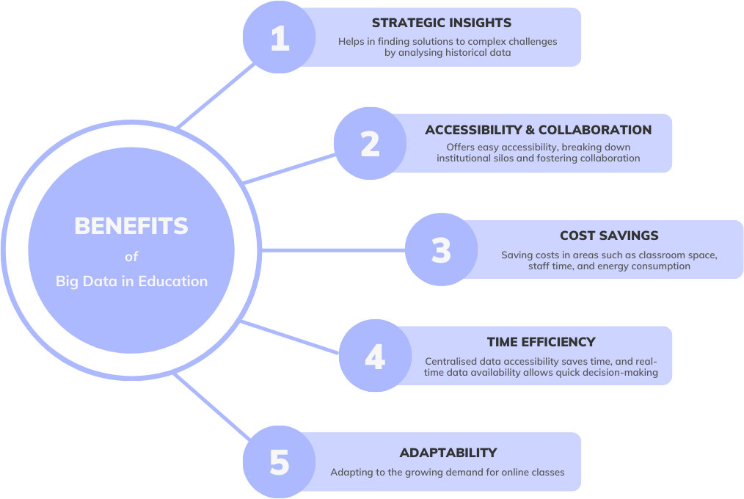

**Figure 3** | List of key benefits of big data in education

### Limitations of Big Data in Education

While big data in education holds significant promise, it is essential to recognise the limitations and challenges associated with its implementation and use (W. Labib,D. Eman Abowardah, 2023). Understanding these limitations is crucial for responsible and effective utilisation of educational data.

**Data privacy and security**

The collection and utilisation of extensive student data raise pressing privacy and security concerns. Balancing data access with protection is paramount in the educational context.

**Overemphasis on quantitative data** Focusing primarily on quantitative data can unintentionally neglect the broader aspects of education, such as critical thinking and emotional development, which are challenging to quantify but equally crucial. Educators must consider the following aspects:

a) Quantitative bias  
b) Holistic assessment

### Lack of data literacy Ensuring that educational staff and students possess adequate data literacy skills is essential to harnessing big data's potential effectively.

### Potential for bias Addressing bias in educational data is critical to ensuring fairness and equity in decision-making, as the biases in data can perpetuate inequalities. Educators must consider the following aspects:

a) Data bias;   
b) Ethical considerations

### Cost of implementation Implementing big data solutions comes with significant financial costs. It's essential to assess the return on investment (ROI) and allocate resources thoughtfully.

## Solution Analysis of Big Data: How Big Data transforms educational institutions: Use cases and examples

### Staff and students can benefit positively from big data analytics in education in a number of ways. In the education context, in addition to convenience and efficiency, institutions are able to improve students’ performance, enhance their study experience, increase graduation rates, and improve teaching methods. Let’s take a look at a few examples of how big data helps educational organisations become stronger (Picciano, A. G., 2012).

### Convenience

Institutions are utilising learning management systems (LMS) like Blackboard, ICE, and Moodle to enhance student experience and faculty efficiency by providing easy access to study materials. Additionally, business intelligence can access business databases decoupled from learning Learning Management Systems (LMS), so that users can retrieve information easily by Analytics tools([Riseapps](https://www.linkedin.com/company/riseapps/).2021).

Learning Management Systems wouldn’t be possible without data mining and analysis. At the University of Westminster, [Blackboard](https://learning.westminster.ac.uk/?new_loc=%2Fultra%2Fcourses%2F_94767_1%2Foutline%2Fedit%2Fdocument%2F_4782374_1%3FcourseId%3D_94767_1%26view%3Dcontent) stands as a central and indispensable tool in the realm of education and teaching.

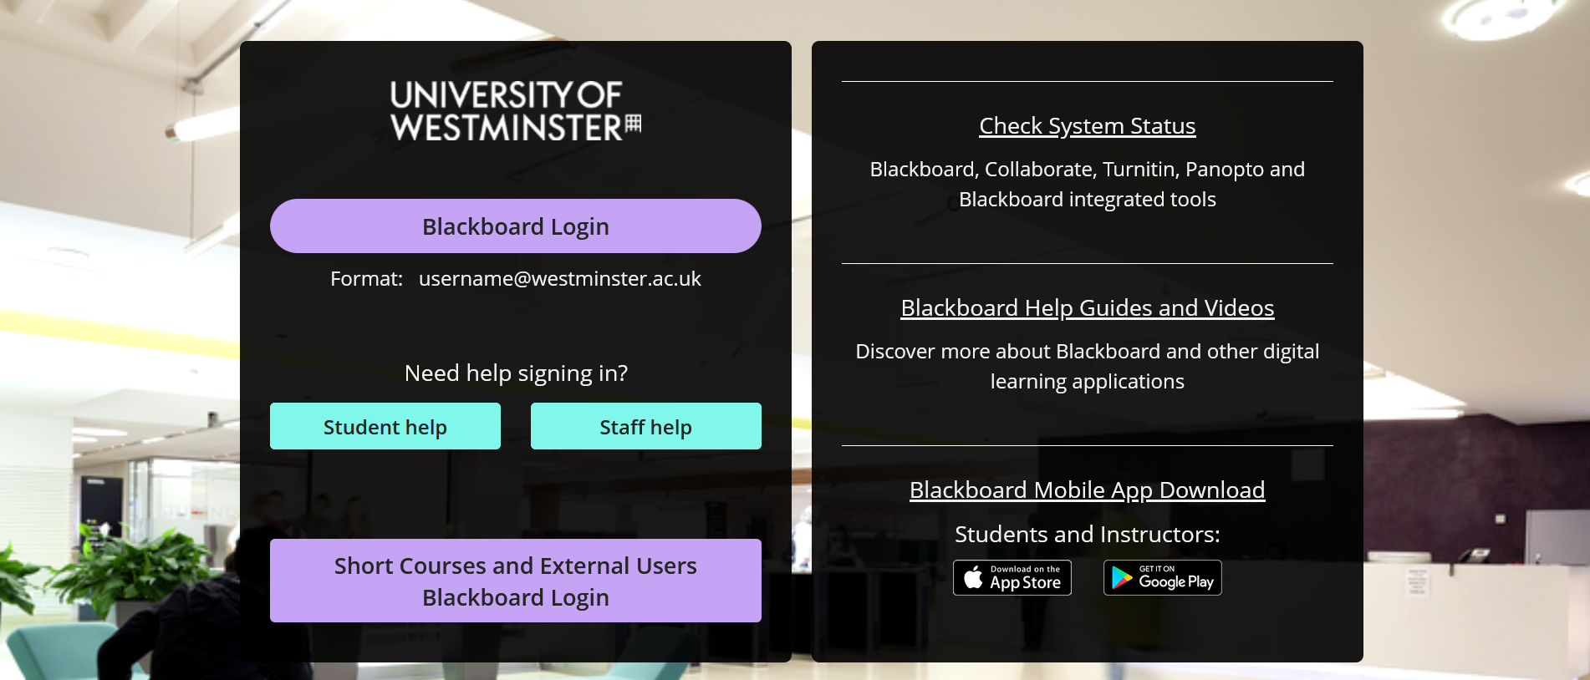

**Figure 4** | Gives an example of online Learning Management System - Blackboard

### Improvement of Student Success

Big Data in education can track learners’ performance by subjects on individual and group levels. This information helps educators implement insightful solutions to learning plans, guide learners on their education and career path and influence their academic performance.

Georgia State University faced the problem of students collecting credits but not heading towards graduation. So the administration decided to turn to Big Data to deal with the situation. They implemented a system that tracks students’ decision-making process and predicts their academic results. As a result, students’ [average time for graduation decreased by half](https://www.timeshighereducation.com/features/how-do-universities-use-big-data).

### Efficient grading system

Big Data allows researchers to trail learners’ behaviour and performance for a long time. The patterns learners repeat when passing exams, tests, and other assignments show the gaps in task creation, making it possible to strengthen them in future iterations.

[Illuminate Education](https://www.illuminateed.com/) utilises a data-driven approach to provide assessment, management, and real-time feedback solutions for K-12 education all over the country. Their assessment engine called “DNA” helps educators get quick feedback from learners, improve lesson planning and pace, influence learners’ progress, and adapt to learners’ needs([Riseapps](https://www.linkedin.com/company/riseapps/).2021).

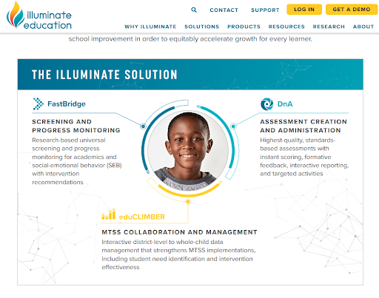  
**Figure 5** | The Illuminate Solution - an example of efficient grading system

For example, Monterey County schools in California use Illuminate to collect learners’ data, record their grades, and receive custom reports.

### Adaptive dynamic learning

Adaptive learning means using computer algorithms to provide learners with an individual learning experience([Riseapps](https://www.linkedin.com/company/riseapps/).2021). For example, ML and AI process Big Data collected from users’ previous interactions with software and deliver personalised content and learning activities for each learner.

### Lowered dropout rates

Predictive analytics uses historical data to anticipate future outcomes. In education, the companies and universities use algorithms to track learners’ grades over several years([Riseapps](https://www.linkedin.com/company/riseapps/).2021). They can calculate the percentage of learners who get low rates on a particular subject and how it influences their graduation success.

[Georgia State University](https://www.washingtonpost.com/news/grade-point/wp/2017/12/12/big-data-could-solve-the-college-dropout-problem/) spent ten years examining data from over 140 thousand students. As a result, the university had found 800 factors that influence students’ likelihood of a dropout. To combat this problem, they’ve provided students who needed attention with counselling and lowered dropout rates by 32 percent.

## 

## Data Governance & ROI

### Importance of Data Governance in Education

Data governance is paramount in the education sector for several reasons. It ensures the reliability of data, facilitates informed decision-making, enhances data security, and ensures compliance with regulations such as FERPA and GDPR.

The UK's data processing regulations are inadequate in educational contexts, resulting in a lack of clarity and responsibility between schools and EdTech providers. Without effectively addressing the hurdles in education data governance, fostering enthusiasm for harnessing the full potential of educational data becomes challenging. A trusted and efficient governance framework is necessary for this endeavour, involving public deliberation, input from children and young individuals, and robust research to assess data outcomes.

### Data Governance Framework

A comprehensive data governance framework for the education sector should encompass components such as data quality, data security, compliance, and stakeholder involvement. This framework provides a structured approach to managing and utilising educational data.

**Applying the UK General Data Protection Regulation (GDPR)**

Applying the UK General Data Protection Regulation to educational data, companies offering Educational Technology (EdTech) services have direct access to children's educational information through schools. The primary responsibility lies with the school, acting as the main duty bearer, which must initiate a Data Protection Impact Assessment (DPIA) before engaging with an EdTech company. Determining whether the school or the company serves as the data controller is crucial, and a legal basis for data processing must be established.

UK GDPR's Age Appropriate Design Code (AADC) governs EdTech companies' handling of children's educational data, balancing commercial interests with privacy while enabling companies to achieve commercial goals.

Despite some confusion about the applicability of the AADC to EdTech and schools, it underscores the necessity for clear government guidance on when and how the AADC applies to educational technology companies and schools. In cases where the AADC's special protections for children's data do not apply to schools, there is a need for guidance on alternative regulations or standards.

### Challenges in Data Governance for Education

While there are advantages, the education sector encounters difficulties in establishing strong data governance practices. Challenges include the presence of isolated data storage, problems with system compatibility, and the necessity for secure and adaptable data storage solutions.

### Return on Investment (ROI)

Firstly, obtaining a degree from a good UK university provides an almost limitless number of career options. The UK includes many of the world’s best universities, which are recognized worldwide for their academic achievements and research. Graduates from these elite institutions are sought after by employer’s world over hence improving their chances of being employed and earning capacity (Tran *et al.* 2020). Moreover, higher education promotes intellectual and personal development. Holistic education in the UK fosters research practices, preparing students for various professional difficulties by equipping them with critical thinking and problem-solving skills.

The UK education system places importance on the practical knowledge and relevant skills for industry, so that graduates have the ability to meet the requirements of businesses. This practical orientation boosts the immediate usability of their education as it enables them to instantly contribute towards their respective fields (Williamson, 2021).The education path offers a higher ROI for career growth, with higher degrees resulting in increased earnings and increased potential for employment. Networking opportunities and mentorships further enhance the return on investment.

**Conclusion**

In conclusion, the use of big data is reshaping higher education, addressing challenges like privacy concerns and infrastructure limitations. It includes better employability and development of competencies that are vital to thrive in today’s fast paced world. Pursuing higher education in the UK is an investment into one’s future that gives returns on life. Learning Analytics and Adaptive Learning Systems are revolutionising teaching, enhancing efficiency and scalability. Cloud computing improves grading, personalised learning, and student success, while governance structures ensure effective data utilisation in the UK's college system.

## References

1. Baig, M.I., Shuib, L. and Yadegaridehkordi, E. (2020). Big data in education: a state of the art, limitations, and future research directions. *International Journal of Educational Technology in Higher Education*. [online] Available from <https://educationaltechnologyjournal.springeropen.com/articles/10.1186/s41239-020-00223-0> [ Accessed 20 dec 2023]
2. W. Labib, D. Eman Abowardah and A. Abdelsattar, (2023). A Review of Big Data’s Role on Higher Education, Sixth International Conference of Women in Data Science at Prince Sultan University (WiDS PSU), Riyadh, Saudi Arabia, 98-105. [online] Available from <https://research.tees.ac.uk/ws/portalfiles/portal/9950423/How_Big_Data_Analytics_Influence_Education_Review_V04.pdf> [ Accessed 18 dec 2023]
3. Drigas, A. and Leliopoulos, P. (2014) 'The Use of Big Data in Education,' *International Journal of Computer Science Issues (IJCSI), 11(5), 58.* [online]. Available from <https://www.ijcsi.org/papers/IJCSI-11-5-1-58-63.pdf> [ Accessed 23 dec 2023]
4. Nazarenko, M.A. and Khronusova, T.V. (2017). Big data in modern higher education,Benefits and criticism. *International Conference Quality Management, Transport and Information Security, Information Technologies"(IT&QM&IS) ( 676-679).* [online] Available from <https://ieeexplore.ieee.org/document/8085914> [ Accessed 21 dec 2023]
5. Picciano, A.G. (2012). The evolution of big data and learning analytics in American higher education,16(3).[online] Available from <https://olj.onlinelearningconsortium.org/index.php/olj/article/view/267> [ Accessed 20 dec 2023]
6. Fischer, C. *et al.* (2020) Mining Big data in Education: Affordances and challenges,' *Review of Research in Education*, 44(1), 130–160. [online] Available from <https://journals.sagepub.com/doi/full/10.3102/0091732X20903304> [ Accessed 23 dec 2023]
7. Samsul, S.A., Yahaya, N. and Abuhassna, H. (2023). Education big data and learning analytics: a bibliometric analysis. *Humanities and Social Sciences Communications*, 10(1). [online] Available at <https://www.nature.com/articles/s41599-023-02176-x> [ Accessed 26 dec 2023]
8. Day, Emma (2021). Governance of data for children's learning in UK state schools. Digital Futures Commission. [online] Available from <https://digitalfuturescommission.org.uk/wp-content/uploads/2021/06/Governance-of-data-for-children-learning-Final.pdf> [ Accessed 20 dec 2023]
9. Job, M.A. (2018). An Efficient Way of Applying Big Data Analytics in Higher Education Sector for Performance Evaluation. *International Journal of Computer Applications*, 180(23), 25–32 [online] Available from <https://doi.org/10.5120/ijca2018916434> [ Accessed 25 dec 2023]
10. Khan, S. and Alqahtani, S. (2020). Big Data Application and its Impact on Education. *International Journal of Emerging Technologies in Learning (Ijet)*, 15(17), 36 [online] Available from <https://doi.org/10.3991/ijet.v15i17.14459> [ Accessed 17 dec 2023]
11. Bigdata (2020). *The impact of big data on education*.[online] Available from <https://bigdataanalyticsnews.com/impact-of-big-data-on-education> [ Accessed 14 dec 2023]
12. TheKnowledgeAcademy (2023). *Understand the role of big data in the education sector*.[online] Available from <https://www.theknowledgeacademy.com/blog/big-data-in-education> [ Accessed 21 dec 2023]
13. www.linkedin.com. ([Riseapps](https://www.linkedin.com/company/riseapps/).2021). *How Big Data Changes Education: Examples and Insights*. [online] Available from <https://www.linkedin.com/pulse/how-big-data-changes-education-examples-insights-riseapps> [ Accessed 20 dec 2023]
14. Chang, V., Xu, Q. and Méndez, V.M (2019). A review on how big data analytics can influence education. *International Journal of Educational Technology in Higher Education*. 130–138 [online] Available from <https://research.tees.ac.uk/ws/files/9950423/How_Big_Data_Analytics_Influence_Education_Review_V04.pdf> [ Accessed 22 dec 2023]
15. Trần, L.T. *et al.* (2020). Post-study work for international graduates in Australia: opportunity to enhance employability, get a return on investment or secure migration?. *Globalisation, Societies and Education*, 18(5),495–510 [online] Available from <https://www.tandfonline.com/doi/full/10.1080/14767724.2020.1789449> [ Accessed 29 dec 2023]
16. Williamson, B. (2020). Making markets through digital platforms: Pearson, edu-business, and the evaluation of higher education. *Critical Studies in Education*, 62(1), 50–66. Available from <https://www.tandfonline.com/doi/full/10.1080/17508487.2020.1737556> [ Accessed 28 dec 2023]